**An Overview of Light**

**Introduction**

The sense we probably rely on the most is our eyesight. With it, we detect colors, distance, brightness, and shapes...all of which we use to physically navigate the world around us. At the same time, our eyes wouldn’t be able to see any of these things if not for the outpouring of light all around us coming in like lasers, bouncing off surfaces, and going straight into our pupils. Indeed, our eyes without a light source is just as useful as a doorknob without a door--completely useless.

In Astronomy, we have a similar relationship with light, except our eyes are now telescopes. Almost all of our observational data about planets, galaxies, stars, and cosmological origins come from these telescopes which collect light inside them. The light that enters is then converted into a digital format that we can read and interpret using the physical principles of our universe!

We’re speaking in vague terms so far, but in the next few sections, we’re going to talk about what light is, what digital format we convert it to so that we can interpret it, and how we can use light data to understand the vast ocean of neutral hydrogen in our Milky Way (the objective of Project 2).

**Section 1: What is Light?**

For a long time in our history, a contentious debate permeated all of physics...is light a wave? Or is it a particle? If you’ve taken chemistry or physics already, you may already know where this debate ends. If that is this case, consider this a review!

**Section 1.1: Particles and Waves in Everyday Life**

Marbles, baseballs, and individual atoms and molecules are all examples of *particles*. When particles move, such as when a baseball is hit into the air, its position is well-defined and measureable at any point in its flight.

On the other hand, what are waves? If we throw a rock into a pond, it creates waves which ripple outward from where it splashed.

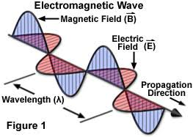

Light is still something that we are unsure about. The reason for that is that in some context light can be described as an electromagnetic wave much like the diagram above shows. It is composed of an electric and magnetic field that oscillate in tandem to keep the wave propagating. Thinking of light in this way is the way that radio astronomy looks at light, because the electric field will oscillate the atoms in the antenna and some devices convert those oscillations into electrical signals which we can then use on our computers.

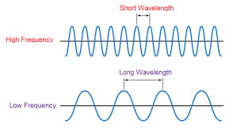

However, there are times where it is better to think of light as a particle than a wave. For example, when we convert the light received by the telescope into something that we can work on our computers we treat light as a particle. When we think of light in this way we treat light as “photons”, a bundle of light carrying some amount of energy. I like to think of this like the image below where the 4 spheres spread from lower left to upper right are the photons.

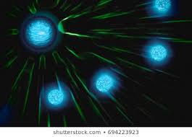

What happens when we detect light in an optical telescope, for example, is that light hits something called a Charged Coupled Device (CCD) and we convert photons into electrical signals by counting the electrons that are ejected as light strikes it. The number of electrons we count will be the number of photons received and we can use this to get an intensity measurement. The more photons hitting one place in the CCD the more light coming from that region of the sky.

**Emission and Absorption Spectra:**

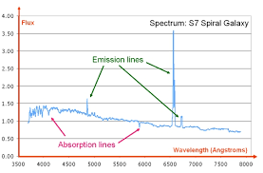

Example of a Spectrum. This outlines emission and absorption features

In the above section we talked about light being able to completely eject an electron from an atom and we use that as a way to count photons hitting the detector. In this section we will talk about what happens when light does not have enough energy to completely eject an electron.

When light hits an atom with some energy three things can happen:

1. Light has enough energy that the electron is completely ejected, this is called ionization
2. Light does not have enough energy to eject the electron but can move it up in energy level, this is called excitation.
3. Due to Quantum Mechanics, atoms will only undergo the above two processes if the photons have specific energies, if photons do not have these specific energies then the photon passes right through the atom, not affecting it at all.

Emission and absorption features occur due to number 2 in the above list. We will go in more detail below as to how this happens and what this does to a spectra.

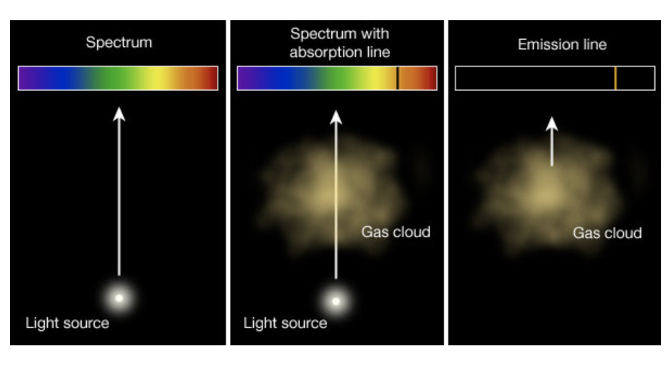

When we look at a light source, like stars or galaxies, in the absence of gas we expect to see a continuous spectrum, much like the one on the left panel.

**Absorption:**

Once we introduce relatively cold gas between us and the light source we will not receive all the light the light source emits because the cold gas will absorb some of the light. We can see this in the spectrum as black bands, much like the spectrum in the middle panel. And due to number three in the list above the cold gas can only absorb light with a certain energy.

**Emission:**

Emission features occur when you have hot gas and what we are seeing are recombination lines. Because the gas is hot, the atoms in this gas are very excited, (ie. are at high energy levels) but atoms do not like to stay there. They are really lazy and would much rather be in the lowest energy state known as the ground state. And so what happens is that the atom cascades the electron down to a lower energy level. When electrons in an atom go to lower energy levels they emit light.

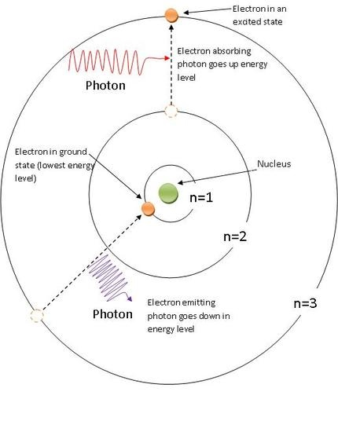

This figure shows both absorption and emission process occuring. The top of this figure shows absorption occurring as a photon strikes the atom and moves the electron from state n=2 to n=3. The bottom of this figure shows emission occurring as the electron goes from state n=3 to n = 1 and a photon being emitted.

**Our Hydrogen Skies**